5/22/2018

Rohan Pretorius 26198738

Louis Scheepers 26368676

Practical 2

Lecturer: Henry Foulds

**Index:**

1. Introduction: 1

2. What is HTML? 1

3. How to construct an HTML page: 1

4. What is PHP? 2

5. How to construct a PHP request to download a file: 2

6. What is AJAX? 3

7. Constructing an AJAX script to update the progress-bar: 3

8. PHP request for getting Server resource utilization: 4

9. References: 5

# 1. Introduction:

This report will handle about a practical assignment that requires us (the student’s Louis and Rohan) to create a PHP document/file that will download a file from upload the file onto a Linux VM that was created in a previous assignment. This implementation requires the use of the Apache Server that was installed on the Linux VM. We are then instructed to add a progress bar on the HTML page that shows the completion of the download progress.

After the functionality of the download and progress bar have been achieved. The second part of the practical instructed us to make a second PHP file that will show the current state of the servers’ resources (RAM usage, CPU utilization etc.). The PHP request need to store this information and then pass it through to the HTML page in order to present it to the user.

# 2. What is HTML?

Before we discuss what HTML exactly is, and how it functions we first look at what each letter in the abbreviation stands for. The abbreviation HTML stands for Hypertext Mark-up Language, and is used to describe the visual appearance of a document and how it can be displayed over the internet in your browser using certain “plugins or scripts”.

According to tech-fag.com the build-up of an HTML document consists of: “Document tags which act to directly describe the visual appearance of a web page or to provide a direct command such as inserting imagery or a link to another web page within a document”. The newer version of HTML called XHTML uses a set of extensible mark-up language definition rules and syntax in order to permit further and more advance web development.

# 3. How to construct an HTML page:

An HTML document are defined by tags that consist of an opening and closing tag in order for the document to be considered “well-formed”. A closing tag will have the same name as an opening tag, but will be preceded by the / symbol. All HTML documents must have a HTML and BODY tag in order for the page to display information and to be read by the browser as an HTML document. Other tags make a part of HTML includes the HEAD, TITLE and P (for paragraphs tag).

# 4. What is PHP?

According to the website freeservers.com, PHP can be described as a general-purpose scripting language that is used in the creation of webpages; PHP is embedded into the HTML code. The abbreviation PHP stands for “Hypertext-Preprocessor”.

PHP is an open-source program, which means it is freely available on the Web. PHP can also be used across multiple platforms, such as Linux, a number of variations of the Unix system, Mac OS X and Microsoft Windows. PHP is a complete programming language which is used for functions such as server-side scripting or writing desktop applications.

“However, the true strength of PHP's lies within its ability to access databases. PHP can access more than 20 different databases (including the popular database MySQL), and can manipulate the information within those databases based on input from an online user. PHP can also be used to output images, PDF files and even Flash movies from your website.” freeservers.com

# 5. How to construct a PHP request to download a file:

According to the php documentation on the site php.net/manual. The following code can be used to force download a file.

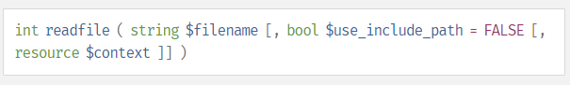

**Figure 5.1**

The following code will read a file in the specified path of $use_include_path, with the file name in the string $filename, if it is not in the root or www directory of the server.

The following was used in our file.php script to download a file

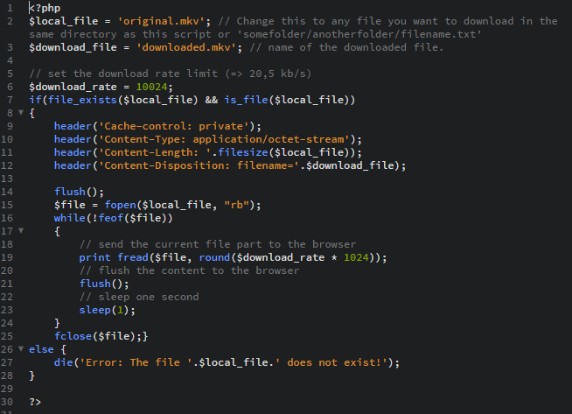

**Figure 5.2**

# 6. What is AJAX?

According to w3schools.com AJAX can be classified as Asynchronous JavaScript and XML, it is a technique that is used for creating fast and dynamic web pages. The main function of AJAX is to update the web page in an asynchronously fashion. It achieves this by exchanging small amounts of data with the server behind the scenes. Thus, making it possible to update certain parts of the web page, without reloading the entire webpage.

The following diagram depicts how AJAX works:

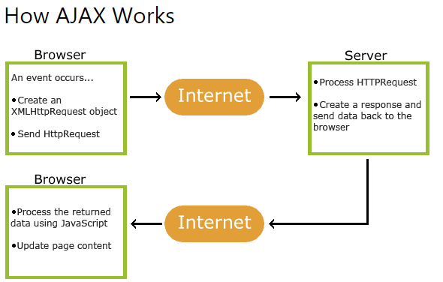

**Figure 6.1**

# 7. Constructing an AJAX script to update the progress-bar:

In order to implement a progress bar into our html code we needed to import some ajax scripts which are download from a google directory add thus use to display the progress bar.

The next need to know the size of the file in order to determine our progress of how far we have downloaded the file this is done in the function “e.lenghtComputable”. Which will determine the current progress by dividing “e.loaded” with “e.total” times a 100. With this function we can get the current progress of how far the file is downloaded.

All of this code is illustrated in figure 7.1 on the next page.

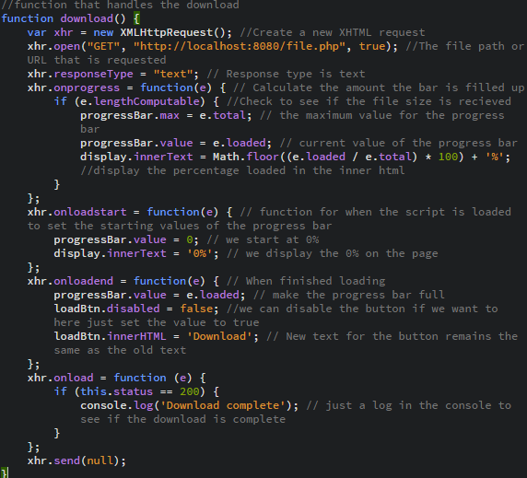

**Figure 7.1**

# 8. PHP request for getting Server resource utilization:

For the server utilization we made a function called “getServerLoad()” which basically executes a command in the shell to get all the resource utilization values.

It stores these values into a string and then display them back to the webpage with some string handling so that the user can understand at which values he is looking at.

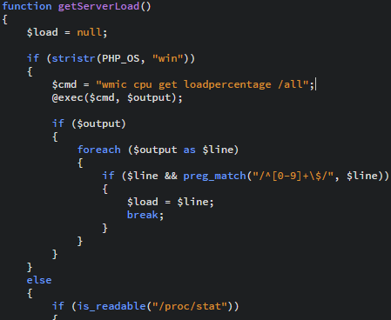

**Figure 8.1**

# 9. References:

freeservers Reliable, Free Web Hosting. What Is PHP?. [http://www.freeservers.com/Web Hosting101/WhatIsPHP.html](http://www.freeservers.com/Web%20Hosting101/WhatIsPHP.html). Date of access: 2018-05-22.

Tech-FAQ. How Does HTML Work?. <http://www.tech-faq.com/how-does-html-work.html>. Date of access: 2018-05-22.

w3schools.com THE WORLD’S LARGEST WEB DEVELOPER SITE. AJAX Introduction. <https://www.w3schools.com/php/php_ajax_intro.asp>. Date of access: 2018-05-22.

php. readfile. <http://php.net/manual/en/function.readfile.php>. Date of access: 2018-05-22.